SCANIA
 | P 410 B6x2*4NB CHASSIS FOR MOBILE CRANE TYPE PALDRIVE 261-266
 |  |  | 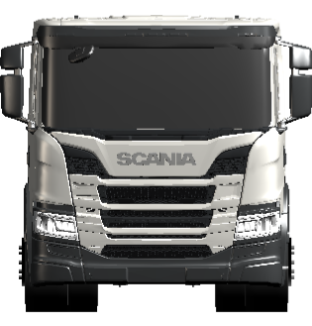 | 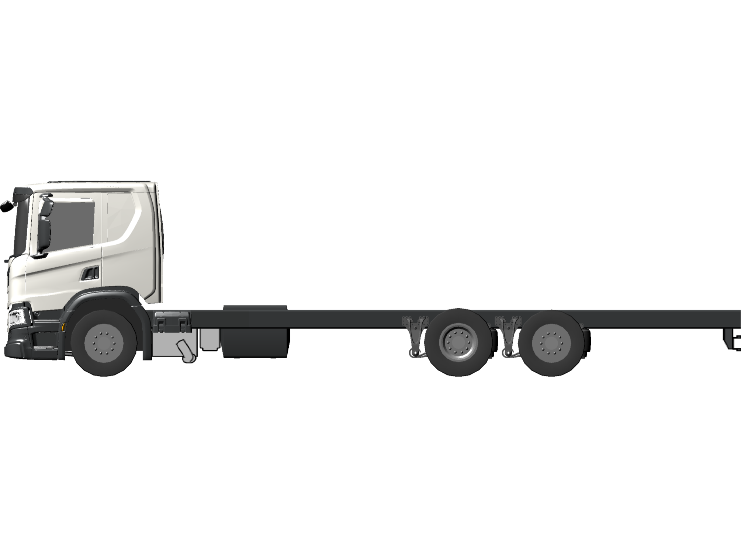
 |  | Guided Offering
 |  | Initial selections
 |  |  | Application |  | Mobile crane | 02758BC
 |  |  | Operation |  | Regional | 02759B
 |  |  | Industry |  | Building & Construction | 02790AG
 |  |  | Cab type |  | CP20L | 00889FD
 |  |  | The P-series sleeper cab with low roof is a sleeper cab with low boarding step. It has one bed. Wide and practical boarding step units make it easy to enter and exit the cab. The cab is designed as a large safety cage around the driver and passenger so that they are well protected. The low roof makes it suitable for applications that require the total height of the cab to be limited, but also require a sleeper cab, such as car transportation, for example. Customer benefits. Very good possibilities for storage behind driver area and passenger area.Space for a comfortable bed up to 100 cm wide. Easy to climb in and out of the cab, thanks to the low cab height and the wide boarding steps. A safe workplace, because the cab is designed as a large safety cage around driver and passenger. The cab is certified in accordance with ECE-R 29.03.
 |  | General
 |  | Type
 |  |  | Chassis adaptation |  | Basic | 01163B
 |  |  | Wheel configuration |  | 6x2*4 | 00448N
 |  |  | Chassis height |  | Normal | 00272B
 |  |  | Suspension system |  | Air front + Air rear | 00828B
 |  |  | Steering wheel position |  | left hand | 00403B
 |  | Certificates and plates
 |  |  | CO2 declaration data |  | with | 07202A
 |  |  | Plate language |  | English | 00003B
 |  | Dimensions
 |  |  | Chassis width |  | 2600 mm | 00058D
 |  |  | Max truck height |  | 4 meters 96/53/EG | 03239A
 |  |  | Axle distance |  | 5150 mm | 01406KB
 |  |  | Dimension JA/BEP L020 (Bodywork Exchange Parameters) |  | 4100 mm | 01537RD
 |  |  | Bogie distance rear axle 1-2 |  | 1350 mm | 05737E
 |  |  | Steering angle 1st, RH turn |  | 43 max | 01345AR
 |  |  | Steering angle 1st, LH turn |  | 47 max | 01346BD
 |  | Weights
 |  |  | Legal weight 1st axle |  | 9000 kg | 02751E
 |  |  | Legal weight 2nd axle |  | 11500 kg | 02752GE
 |  |  | Legal weight 3rd axle |  | 7500 kg | 02753CE
 |  |  | GVW technical |  | 28000 kg | 06177JK
 |  | Engine
 |  | Engine
 |  |  | Propulsion |  | combustion engine | 04034A
 |  |  | Fuel |  | Diesel | 00520A
 |  |  | Emission level |  | Euro 6 | 02471J
 |  |  | Engine type |  | DC13 163 410 hp Euro 6 /Japan Emission 2016 | 00408TF
Engine type: Straight 6-cylinder diesel engine
Displacement: 12.7 dm³
Max. output at 1800 rpm: 410 hp (302 kW)
Max torque at 900-1340 rpm: 2150 Nm
 |  | SCR, Selective Catalytic Reduction | with | 03488A
 |  | NOx control | With | 03636A
 |  | Torque reduction NOx-control | With | 03719A
 |  | Oil level indication | With | 03829A
 |  | Noise suppression | 81/82 dBA R51.03 | 00472AF
 | Air intake
 |  | Air intake | front | 02253E
 |  | Cab air filter type | normal | 08400A
 | Cooling system
 |  | Coolant freeze point | Freezing point -40 degrees Celsius | 03925B
 | Exhaust system
 |  | Exhaust silencer execution | Compact | 01967D
 |  | Exhaust outlet, direction | right hand | 00392E
 |  | Silencer length | 623 mm | 04329B
 |  | Exhaust silencer longitudinal position (XM) | 2650 mm | 04810E
 | Gearbox
 | Gearbox
 |  | Gearbox | GR875 | 00017TJ
8-speed range gearbox with one reverse gear.
 |  | Gear selector position | Steering wheel | 03574B
 | Opticruise
 |  | Opticruise | With | 02519A
Scania Opticruise is an automatic gear changing system for manual gearboxes.
 |  | Performance modes | Economy, standard, power | 05112A
 |  | Kickdown | With | 04370A
 | Clutch
 |  | Clutch system | automatic | 03575B
Automatic clutch control, together with Opticruise, gives a completely automated shifting system.
 | Axles
 | Front axles
 |  | Axle weight front, technical | 9000 kg | 00073T
 | Rear axles
 |  | Bogie weight, technical | 19000 kg (11500 + 7500) | 00552AM
 |  | Rear axle gear | R780 | 00021AK
 |  | Rear axle gear ratio | 3,08 | 00022AV
 |  | Differential lock | with | 00020A
 | Tag axle
 |  | Tag axle lift | with | 00086A
 | PTO
 | Clutch independent PTO
 |  | Power Take-Off ED | Prepared | 04827A
The engine is supplied prepared for power take-off. The preparation consists of an intermediate gear which is fitted in the flywheel housing.
 | PTO
 |  | PTO EG rear type | EG651P | 06392AK
The EG651P is mounted on the right-hand side of the gearbox at "5 o'clock". The power take-off rotates anticlockwise, seen from the rear, and is designed for direct-mounted equipment with connection DIN 5462. Ratio: 1:1.28. Max. torque 800 Nm. Max. power output in continuous operation without gearbox oil cooling: 80 kWMax. power output in continuous operation with gearbox oil cooling: 120 kWMax. power output in periodic* operation: 120 kW.*50% operating time at maximum permitted output and 50% inoperative during 30-minute intervals.
 | Fuel tanks
 | General
 |  | Fuel tank, right hand side | 400W aluminium | 02627WR
 |  | Fuel tank location | Normal | 01368B
 |  | Fuel filler cap | lockable | 00518A
 |  | Fuel heater | with | 00557A
 |  | Fuel splash protection | With | 03974A
 | SCR tanks
 |  | SCR heating system | With | 04287A
 |  | SCR reductant tank volume side RHS | 80 dm3 | 04318E
 |  | SCR reductant tank filler cap | Lockable | 04334A
 | Chassis
 | Frame
 |  | Frame, type | F950 | 00458B
 |  | Bodywork holes configuration frame | entire frame length | 07432A
 | Steering
 |  | Front axle steering system type | hydraulic | 07281B
 |  | Steering force 70/311/EEC | With | 01367A
 |  | Manoeuvrability according to 97/27/EC | Yes | 02127A
 |  | Steering wheel type | basic | 02153A
 |  | Adjustable steering wheel | tilt | 02991B
 | Suspension front
 |  | Air spring height, front | Normal | 01334A
 | Suspension rear
 |  | Air suspension rear type | 2-spring | 03226A
 |  | Shock absorber rear axle | With | 02259A
 |  | Level adjustment speed | Fast | 02487F
 |  | Level adjustment control truck/trailer | Truck | 04029A
 |  | Alternative predefined chassis levels | exhausted bellows + 2 memory | 02488F
 |  | Load transfer according to EC 97/27 | no | 02972B
 |  | Load limit | at 11500 kg | 00084D
 |  | Load transfer | with | 01353AA
 |  | Load transfer, tag axle position | lifted unloaded | 01528B
 |  | Load transfer limit | 11500 kg | 06028B
 |  | Load transfer manoeuvring | continuous load transfer request | 06029A
 |  | Speed limitation for load transfer | unlimited | 01911E
 |  | Axle load display | Front and rear | 02478A
 | Anti-roll bar
 |  | Anti-roll bar, front | Extra stiffness | 00092D
 | Electrics
 |  | Battery | 230 Ah | 00095AM
 |  | Battery position | Left hand side | 03979A
 |  | Alternator charge | 100 A | 01122D
 | Wheels & Mudguards
 | Tyres
 |  | Tyre type front axle | 385/5522.5 Winter Steer Bridgestone RW-Steer 001 | 08905H
 |  | Tyre type rear axle | 315/70R22.5 Winter Drive Bridgestone RW-Drive 001 | 08906XU
 |  | Tyre type tag axle behind drive axle | 385/5522.5 Winter Steer Bridgestone RW-Steer 001 | 08908H
 | Rims
 |  | Rim type front axle | 22.5 x 11.75 steel | 05001FA
 |  | Rim type rear axle | 22.5 x 9.00 steel | 05002DA
 |  | Rim type tag axle behind drive axle | 22.5 x 11.75 steel | 05004FA
 | Wheel equipment
 |  | Wheel nut cover | steel stainless | 00148B
Wheel nut caps in stainless steel.
 | Mudguard front
 |  | Front mudguard size | 675 mm | 05071B
 |  | Spray-suppression according to EU 109/2011 | With | 05828A
 |  | Spray suppression | with | 01421A
 |  | Mudflap, front | with | 00053C
 | Brakes
 | Brake system
 |  | Brake category | AB | 01493AB
 |  | Brake adaptation | Rigid | 00039B
 |  | Wheel brake | disc | 01405B
 |  | Brake control combination | electronic with disc brake | 02647B
 |  | Hill hold | hill hold | 03485C
 |  | ESP, Electronic Stability Programme | With, disabling | 02439B
 |  | ESP setting for ABS trailer | With | 04386A
 |  | APS, Air Processing System | Air management | 02458B
 |  | Parking brake system | pneumatic | 06171A
 |  | Parking brake trailer control | braked by service line | 05848A
 | Wheel brakes
 |  | Brake chamber type 1st front | membrane + spring | 00028B
 |  | Brake chamber type, 1st rear | membrane + spring | 00008B
 |  | Brake chamber type trailing tag axle | membrane + spring | 01175B
 | Auxiliary brakes
 |  | Auxiliary brake control | automatic | 06302B
 | Trailer brakes
 |  | Trailer brake | with | 00027A
 | Body and chassis adaptation
 | Bodywork interface
 |  | Bodywork Communication Interface, BCI | with | 05837A
 |  | Bodywork info in Instrument Cluster | With | 03888A
By means of lamps, sounds and display messages in the instrument cluster the bodywork has many options for providing the driver with information. There is access to 8 lamps, all with the option to indicate with different colours. There are also a number of pre-defined display messages and a total of five different sounds. All information is adapted to Scania's information levels: alarm system, warning, information and status. In order to be able to activate 2 of the 8 positions using sound and colour, the necessary connectors and cable harnesses are fitted at the factory, 03888.For the option to program and activate all 8 positions, BCI control unit, 05837A, and ICL with full functionality, 03888A, must be selected in combination.9 different variants of symbol lens can be ordered via variant code 07331.
 | Symbol lens instrument cluster | general | 07331A
 | Cable harness for bodybuilder | 7+7+7 | 02411F
Three 7-pin cable harnesses from the bodywork's central electric unit routed under the cab.
 | Cable harness for bodybuilder frame | 12 m | 03023C
12 metre bodybuilder cable for connection of equipment to the rear of the frame.
 | Cable harness for bodybuilder roof | With | 03024A
Wiring is pre-routed from the central electric unit, via the passenger side A-pillar to the roof shelf on the driver's side.
 | Cable harness additional switches | With | 03314A
The dashboard is prepared with wiring for 4 extra switches, 2 on each side of the steering wheel.
 | Remote control engine start | Prepared | 03313B
Prepared for remote control engine starting. Includes extra pressure sensors to check that the parking brake is applied and the gearbox in neutral.
 | Trailer connections
 |  | Trailer electric connector | 1x15 pole ISO 12098 | 00664D
 | Miscellaneous
 |  | Rear underrun protection according to ECE 58R | with | 01538D
The under-run protection is fitted temporarily when the vehicle is delivered. Final mounting is done by the bodybuilder.The underrun protection must be mounted at a maximum distance of 550 mm from the ground on an unladen vehicle in order to comply with EU directive 70/221/EEC. The distance between the lower edge of the bodywork and the underrun protection must not exceed 390 mm.
 |  | Rear underrun protection type | U-profile accordning to ECE R58 | 01539H
 |  | Registration plate holder rear type | Panel | 04499A
 | Cab exterior
 | Cab general
 |  | Cab suspension | air comfort | 02521G
Air Comfort, with 4-point air suspension, integrated shock absorbers and level adjustment.
 |  | Cab tilting | mechanical | 01659B
 | Exterior
 |  | Roof rail | long | 01401E
 |  | Sun visor, external | with | 00060A
 |  | Horn in front, type | compressed air 118 dB | 05174A
 | Front bumper
 |  | Front Underrun Protection, FUP directive | Low approach angle | 02398C
 |  | Bumper protrusion | 40 mm | 04932B
 |  | Bumper beam vertical position | low | 05065C
 | Windows
 |  | Windscreen | Tinted | 02313A
 |  | Door window glass type | single | 05084A
 |  | Window, rear wall | without | 00066B
 | Mirrors
 |  | Rear view mirror glass driver side | spherical | 04935B
 |  | Rear view mirror glass passenger side | spherical | 04936B
 |  | Rear view mirror type | A | 04934A
 |  | Rear view mirror casing shape | smooth | 06784A
 |  | Rear view mirror heating | with | 04937A
 |  | Rear view mirror electrical adjustable | passenger and driver side | 05128B
 |  | Wide angle mirror | Driver + passenger side | 02181C
 |  | Close-proximity mirror | manual adjusted | 04938A
 |  | Front view mirror | manual adjusted | 01902B
 | Lock and alarm
 |  | Locking type cab | remote central locking | 05123C
 |  | Frequency remote lock | 433 MHz | 03889A
 |  | Number of keys/remotes | Two | 02343A
 | Lamps
 |  | Headlamp type | H7 | 02983E
 |  | Dipped beam automatic | with | 05058A
 |  | Headlamp asymmetry | Right hand | 00474A
 |  | Daytime Running Light, DRL function | With LED DRL + position lamps | 03908B
 |  | End outline marker lamp | White | 01313A
 |  | Beacon | With | 01330A
Two rotating warning lamps attached to the roof rails on the sides of the cab roof. The lamps are the halogen type.A switch for operating the rotating warning lamps is located in the cab.
 | Working lamp side below cab | prepared | 04742B
Wiring preparation for work lights on the inside of the frame below the cab, left and right-hand sides. Switch on the door panel is included.
 | Side marker lamps | Temporarily mounted | 00313B
Amber-coloured side marker lamps with light-emitting diodes, temporarily fitted on the frame. The bodybuilder or other workshop must fit them in accordance with national legislation in force.
 | Side marker lamp direction indication | with | 07176A
With direction indicators in the side marker lamps. When the driver signals a turn using the direction indicator lever, the side marker lamps flash as well. When the hazard warning signal is activated, the side marker lamps and all direction indicator lamps flash as well.This is a European legal requirement for vehicles more than 9 metres long. Whole Vehicle Type Approval (WVTA) is not met without this.Advantages for the customerSafety: This indicator provides other road users with an earlier warning of forthcoming turns, thereby enhancing safety.
 |  | Taillamp type | Bulb | 03981A
 |  | Taillamp position | on bracket | 01532A
 |  | Reverse alarm | With disabling | 02412B
 | Cab interior
 | Seats
 |  | Seat category, driver side | medium A | 01431B
Air-sprung seat with the option to adjust position, height, inclination, seat cushion length, backrest and damping.
 | Seat category, passenger side | static | 01432E
Unsprung seat with integrated safety belt. The following settings can be made:
- position
- height
- backrest.
 |  | Seat upholstery driver side | woven | 05028A
 |  | Seat upholstery passenger side | woven | 05029A
 |  | Warning signal for unconnected seat belt | lamp and audio signals | 01511C
 | Beds
 |  | Bed lower | 800 mm, fixed | 06563A
 |  | Bed lower, mattress | bonell | 05211A
 | Storages
 |  | Rear wall storage | Refrigerator | 02042C
 | Interior
 |  | Wall panel and headlining material | textile | 02299B
 |  | Door trim panel type | black plastic | 09109A
 |  | Side panel colour | dark | 05209A
 |  | Sun visor driver door | blind | 06172B
 |  | Boarding grab handle colour | black | 08081A
 |  | Curtain door & windscreen | with | 00143A
 |  | Curtain for bed | with | 00419A
 |  | Protective mats floor | rubber | 02162A
 |  | Mat centre floor | rubber | 02168A
 | Instruments
 |  | Instrument panel finish | hard | 02172E
 |  | Instrument cluster | 4 inch screen km/h | 02301P
Instrument cluster with 4.1" colour display with trip computer and high resolution.
 | Window winder control activation | ignition on or unlocked door | 07411A
 | Tachograph | smart ADR Continental | 02303GS
Smart digital tachograph from Continental VDO that facilitates remote readout, approved for ADR vehicles.
 |  | Tachograph data upload | With | 03956A
 |  | Speed limitation | 89 km/h | 06445GJ
 |  | Speed limitation legal | 90 km/h | 06446H
 |  | Scania Lane Departure Warning, LDW | With | 03601A
 |  | Advanced Emergency Braking, AEB | With | 04335A
 | Climate system
 |  | Climate system heating | with | 05208A
 |  | Air conditioning | with | 00097A
 |  | Climate system control | automatic | 02200B
 |  | Auxiliary heating | WTA cab + engine heater 6 kW | 00118P
 | Lighting
 |  | Internal lighting | normal | 04843A
Lamps in the roof without integrated reading lamp.
 |  | Reading lamp lower bed | Right side | 03758A
 | Communications
 |  | Infotainment system | 2 DIN with 5 inch screen (Advanced) | 05120A
5-inch colour display with touch function.
 |  | Loudspeaker | 2 x 20W | 02176A
 |  | Digital audio broadcast radio | with | 06079A
 |  | Bluetooth | With | 03885A
 |  | USB IP centre position | USB | 06499A
 |  | Communicator | C300 complete | 03808C
 |  | 12/24V sockets | Basic | 05750A
 | Manuals
 |  | Driver´s manual language | German | 06151C
 |  | Driver's manual extra language | English | 06152A
 | Rescue equipment
 | Rescue equipment
 |  | Rescue equipment except fire extinguisher | with | 00083F
 |  | Warning triangle | 2 pieces | 06534B
 |  | Fire extinguisher | prepared | 00468G
 |  | Bulb and tool kit | with | 05133A
 | Colour
 | Cab
 |  | Cab paint type | solid | 06527A
 |  | Cab colour white | Ivory White | 06491A
 | Chassis
 |  | Chassis colour grey | Sub Grey | 06778AP
 | Multi Colour Concept (MCC)
 |  | Front grille upper panel colour | cab colour | 06010A
 |  | Front grille upper ribs colour | cab colour | 06021A
 |  | Front grille lower panel colour | cab colour | 06022A
 |  | Front grille lower ribs colour | cab colour | 06023A
 | Logistics
 | Market logistics
 |  | Country code | NO - Norway | 01256NO

